1. Place the JAR in any of the Windows folder

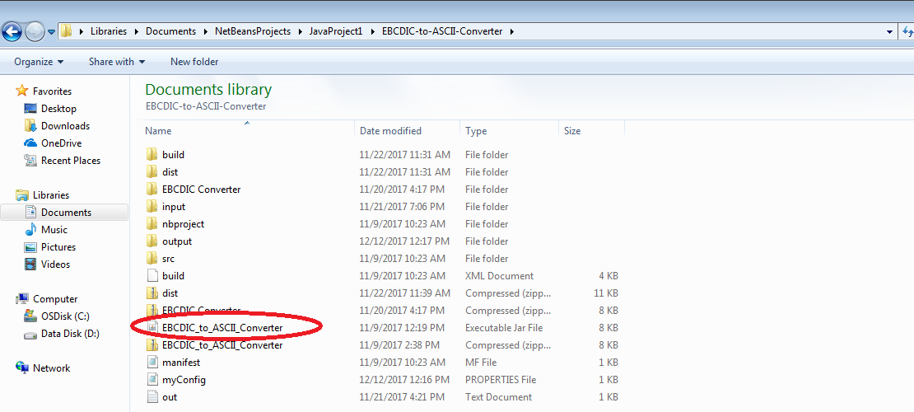

1. Create input folder in the same path of your JAR Path and Place EBCDIC Files in input folder (1 File (or) Multiple Files)

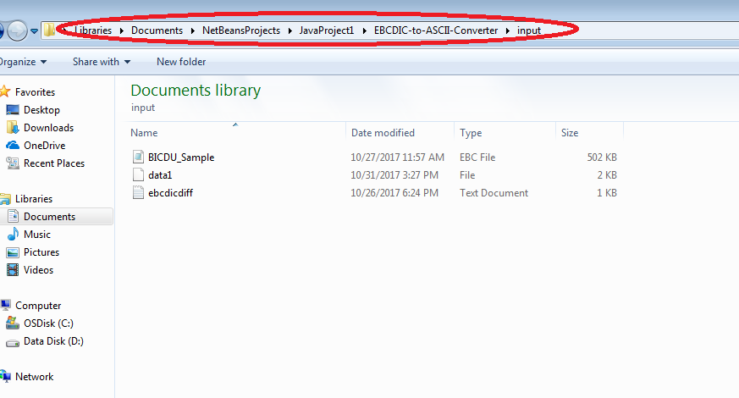

1. Create output Folder in the same path of your JAR Path and keep it empty

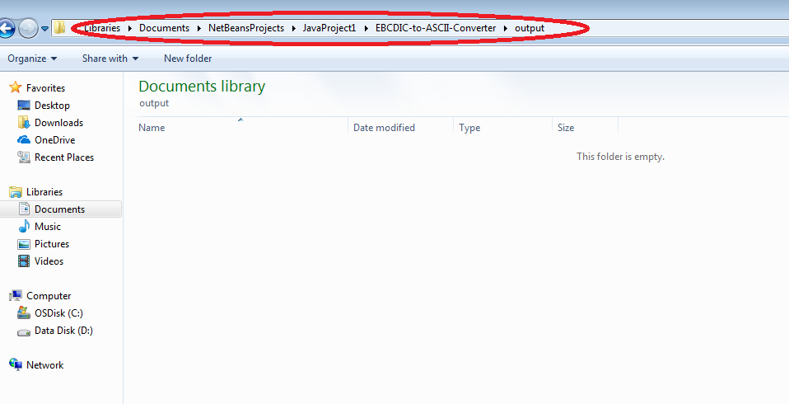

1. Create myConfig property File in the same folder as of JAR folder

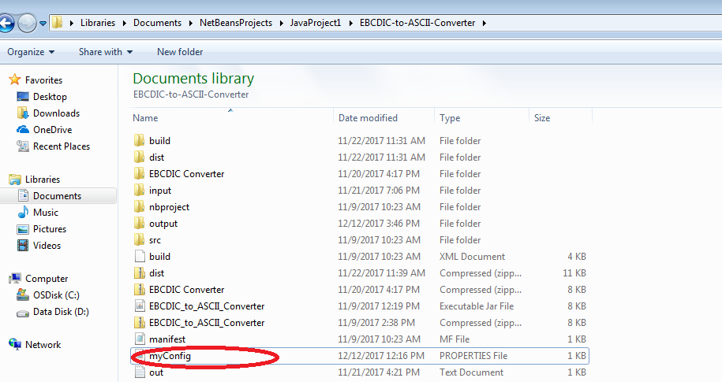

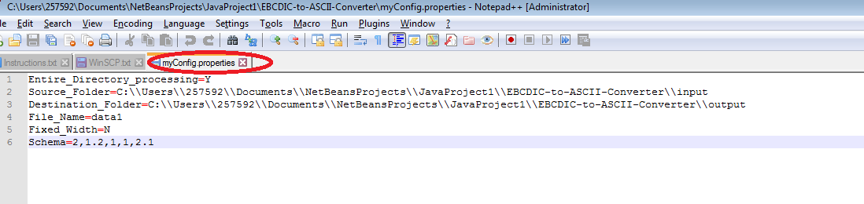

**Property File for Entire Folder Conversion and File is Fixed Width**

**Entire_Directory_processing=Y**

Source_Folder=

Destination_Folder=

File_Name=

**Fixed_Width=Y**

Schema=

**Property File for Entire Folder Conversion and File is delimited**

**Entire_Directory_processing=Y**

Source_Folder=

Destination_Folder=

File_Name=

**Fixed_Width=N**

Schema=(Schema Details in comma separated. Refer Snapshot above)

**Property File for Single File Conversion and File is Fixed Width**

**Entire_Directory_processing=N**

Source_Folder=C:\\Users\\257592\\Documents\\NetBeansProjects\\JavaProject1\\EBCDIC-to-ASCII-Converter\\input

Destination_Folder=C:\\Users\\257592\\Documents\\NetBeansProjects\\JavaProject1\\EBCDIC-to-ASCII-Converter\\output

File_Name=data1

**Fixed_Width=Y**

Schema=

**Property File for Single File Conversion and File is delimited**

**Entire_Directory_processing=N**

Source_Folder=C:\\Users\\257592\\Documents\\NetBeansProjects\\JavaProject1\\EBCDIC-to-ASCII-Converter\\input

Destination_Folder=C:\\Users\\257592\\Documents\\NetBeansProjects\\JavaProject1\\EBCDIC-to-ASCII-Converter\\output

File_Name=data1

**Fixed_Width=N**

Schema=(Schema Details in comma separated. Refer Snapshot above)

1. Once all the above setup done. Trigger the JAR with the below Options in Command Prompt (or) in Net beans Run method

**Run Type 1:**

java -jar EBCDIC_to_ASCII_Converter.jar -l 100 C:\\Users\\257592\\Documents\\NetBeansProjects\\JavaProject1\\EBCDIC-to-ASCII-Converter\\input C:\\Users\\257592\\Documents\\NetBeansProjects\\JavaProject1\\EBCDIC-to-ASCII-Converter\\output

**Arguments:**

-l 100 – length of the record. You can give your length

Input Folder

Output Folder

**Run Type 2:**

java -jar EBCDIC_to_ASCII_Converter.jar -f INPUT_CHARSET -T OUTPUT_CHARSET -l 100 C:\\Users\\257592\\Documents\\NetBeansProjects\\JavaProject1\\EBCDIC-to-ASCII-Converter\\input C:\\Users\\257592\\Documents\\NetBeansProjects\\JavaProject1\\EBCDIC-to-ASCII-Converter\\output

**Arguments:**

-f INPUT_CHARSET – Input Charset (Eg: CP1047)

-T OUTPUT_CHARSET – Output Charset (Eg: ASCII)

-l 100 – length of the record. You can give your length

Input Folder

Output Folder

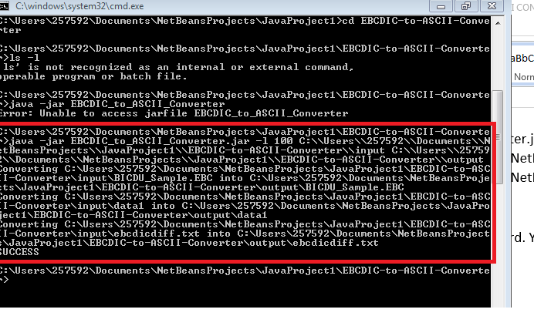

1. Source Code and JAR File

